**Lab 15**

**Configure VPN with Amazon Data center**

Need to configure VPC in Mumbai region / or use default VPC.

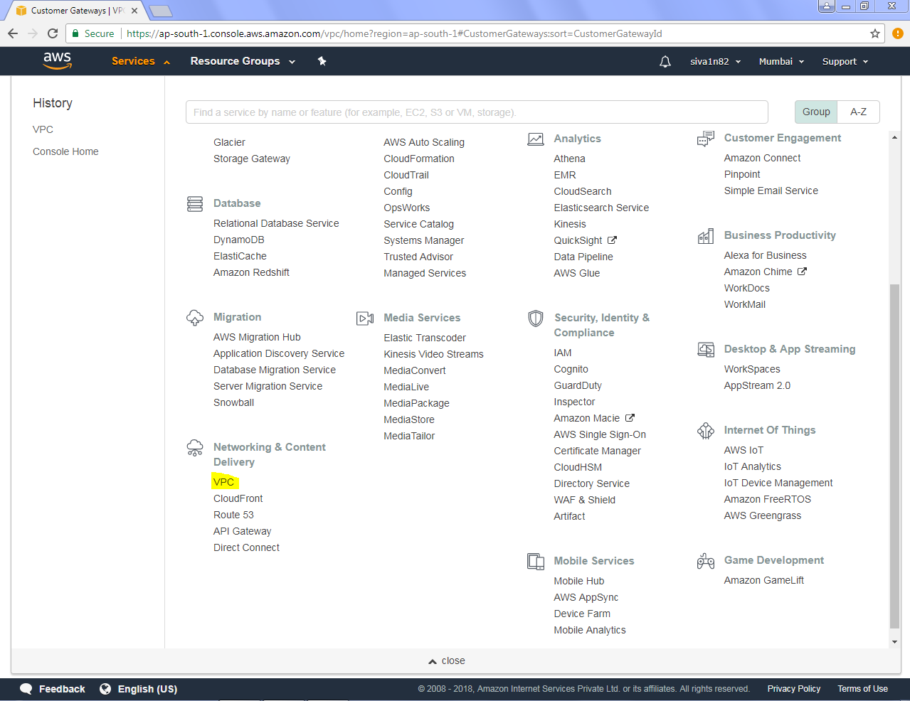

Click “Create Virtual Private Gateway”.

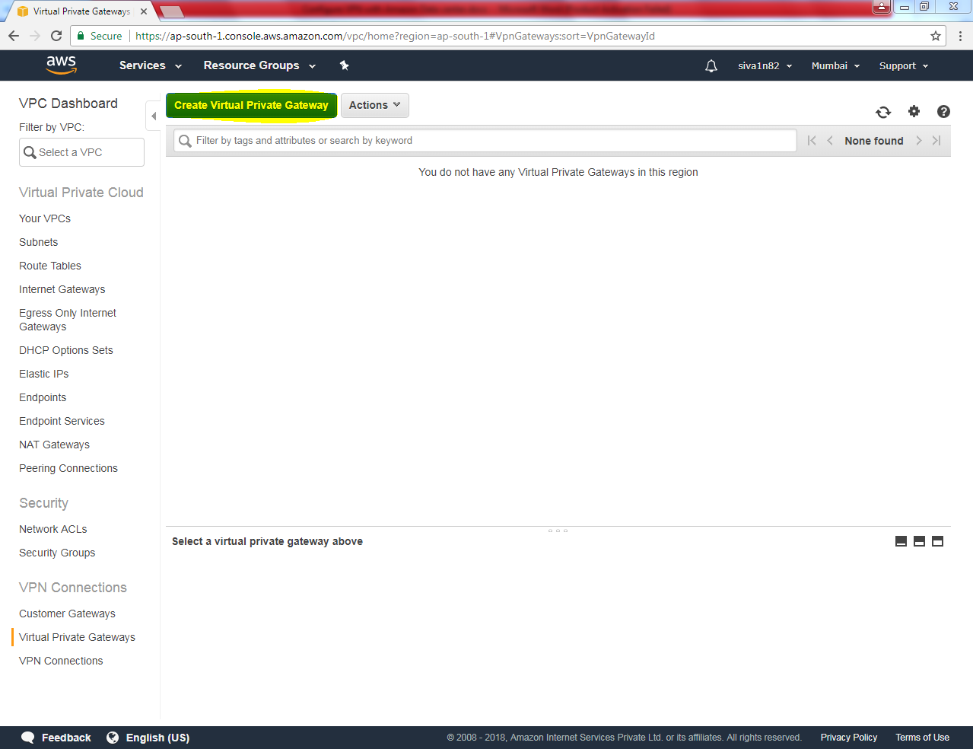

Create Virtual Private Gateway

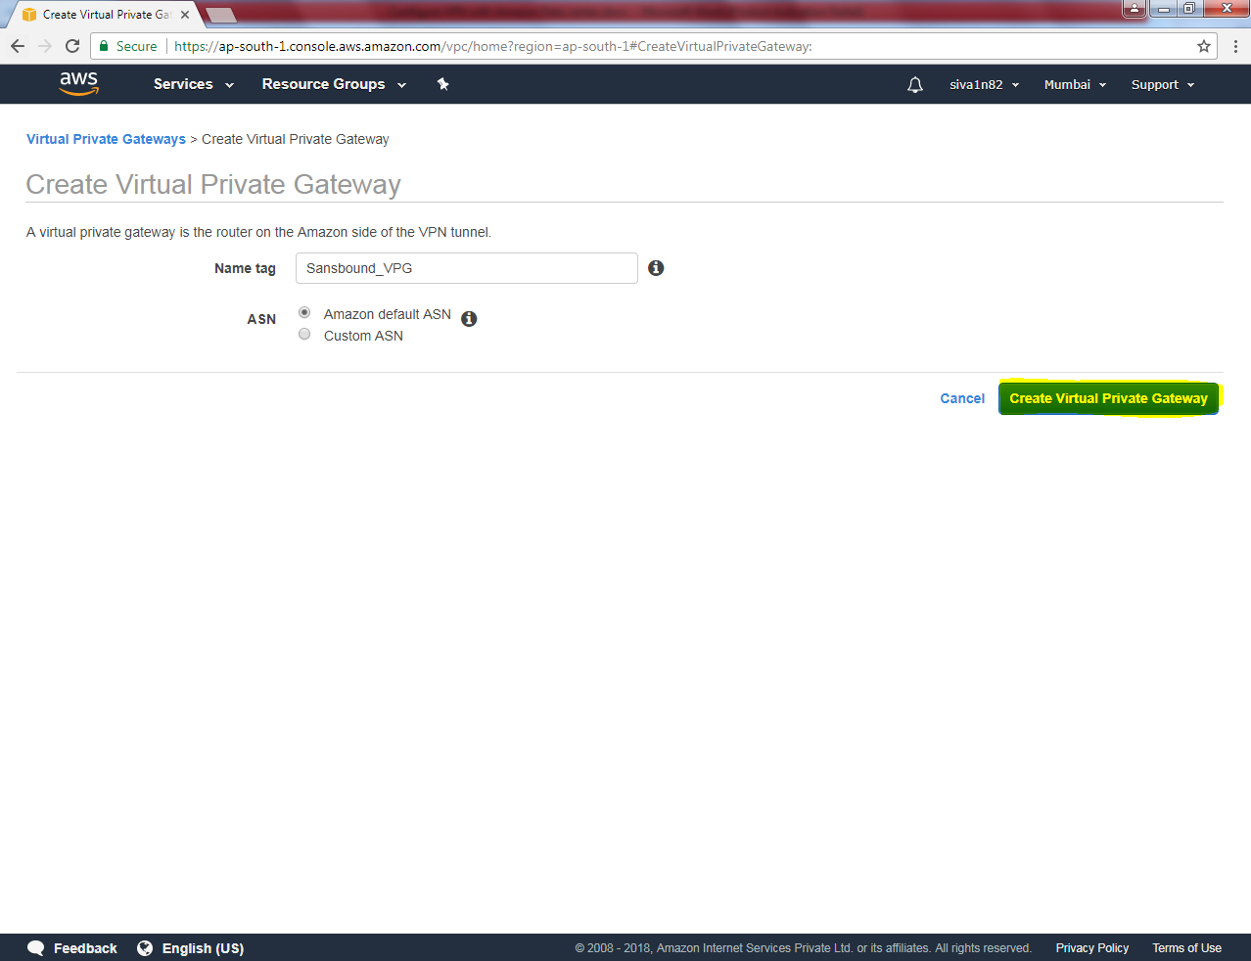

Virtual Private gateway has been created successfully.

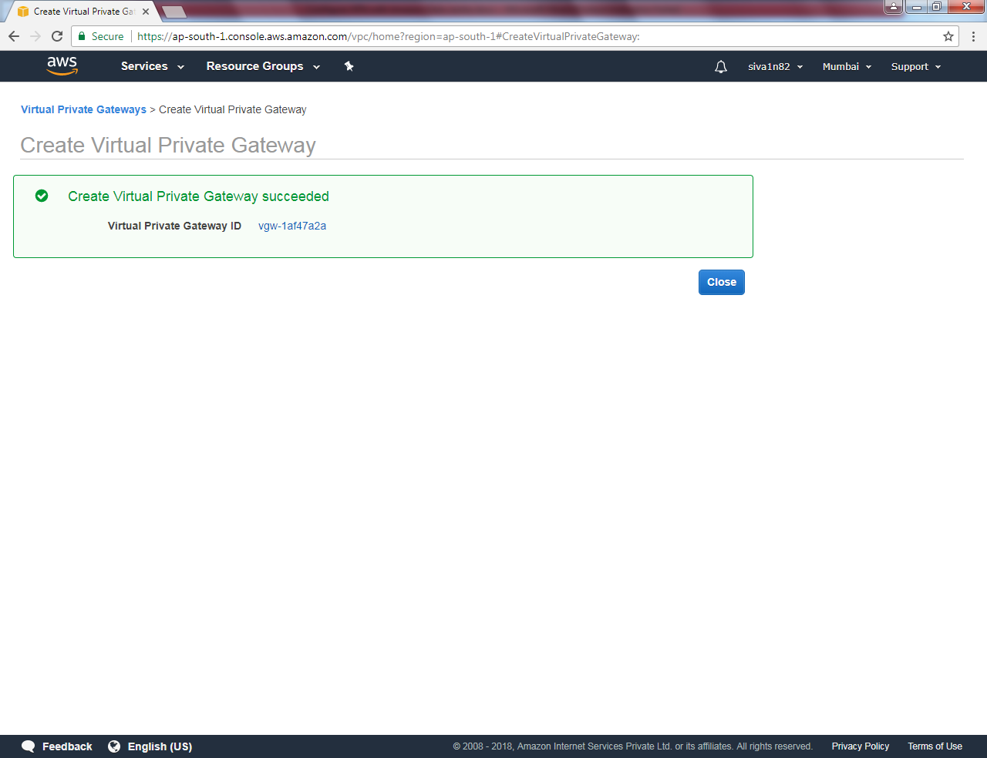

VPG is now in detached state, need to attach to VPC.

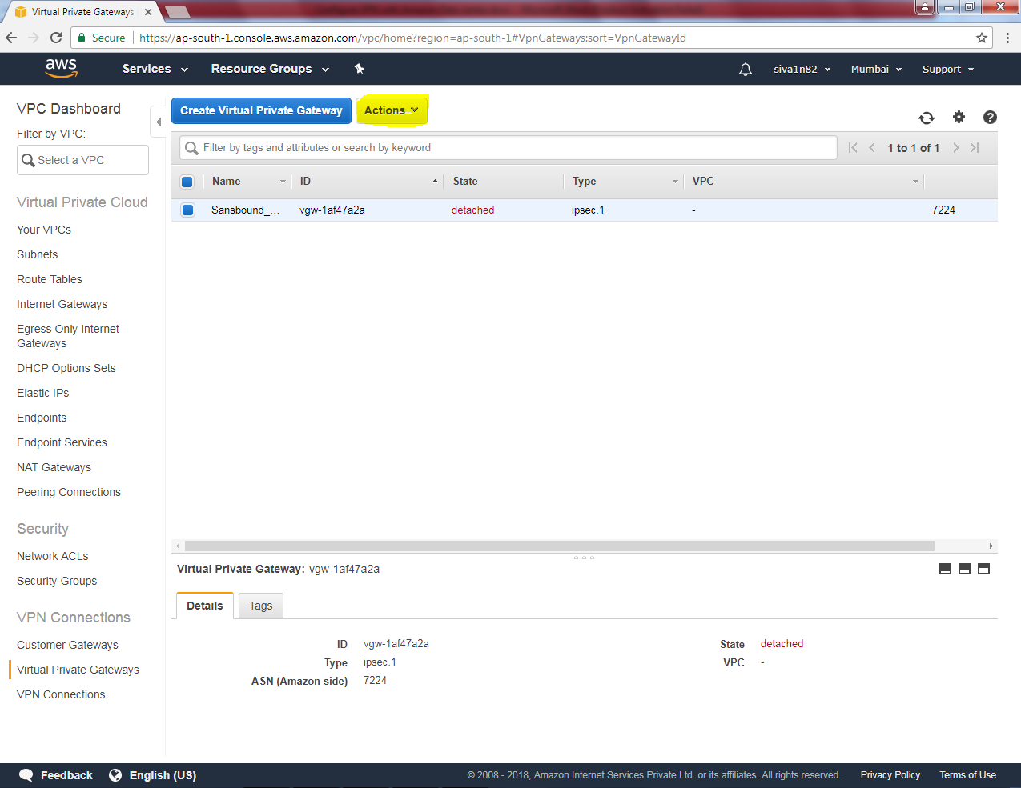

Clicks Actions 🡪 Attach to VPC.

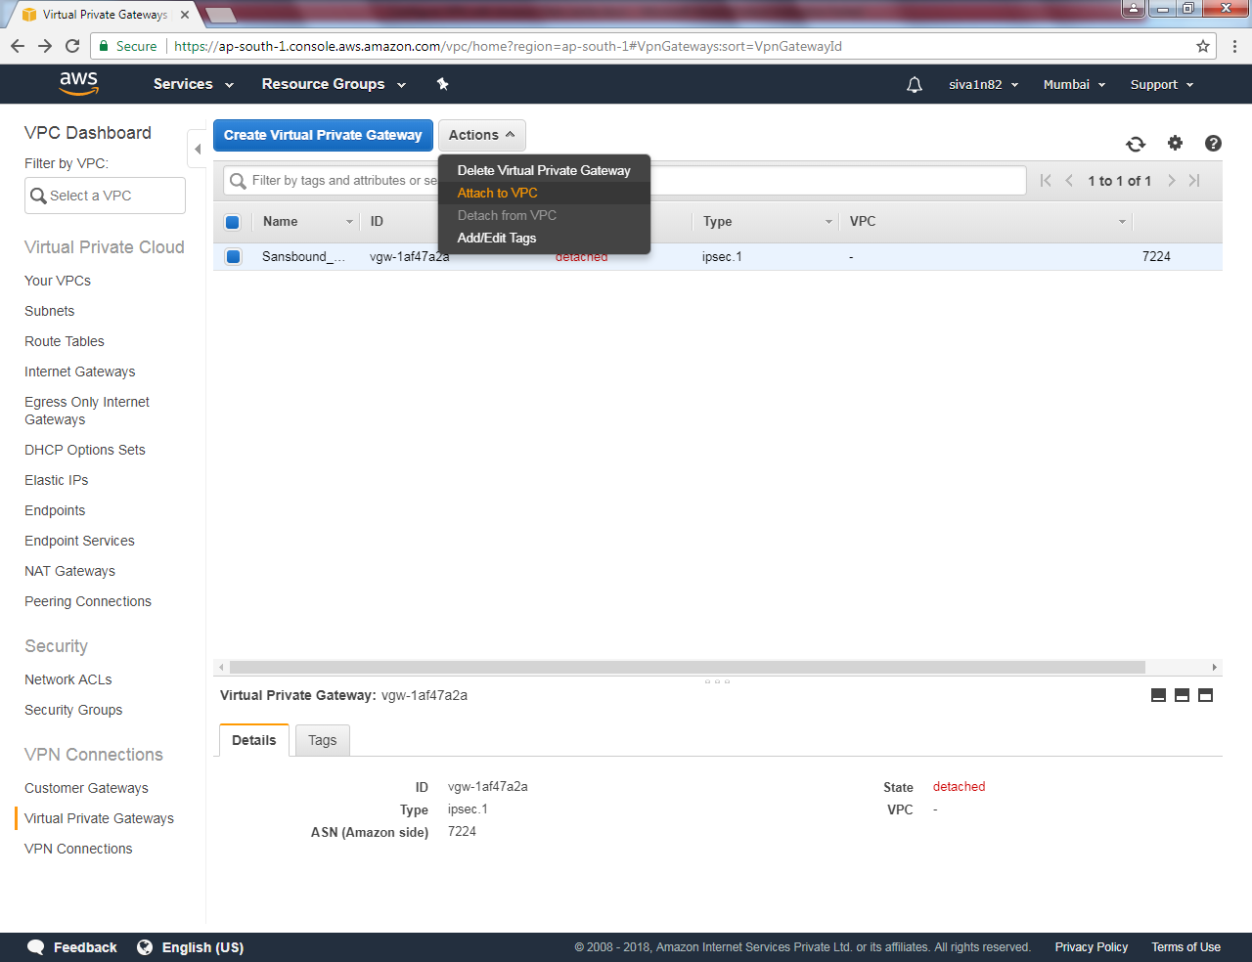

While attaching VPC, Select “Sansbound_VPC_Mumbai” to attach.

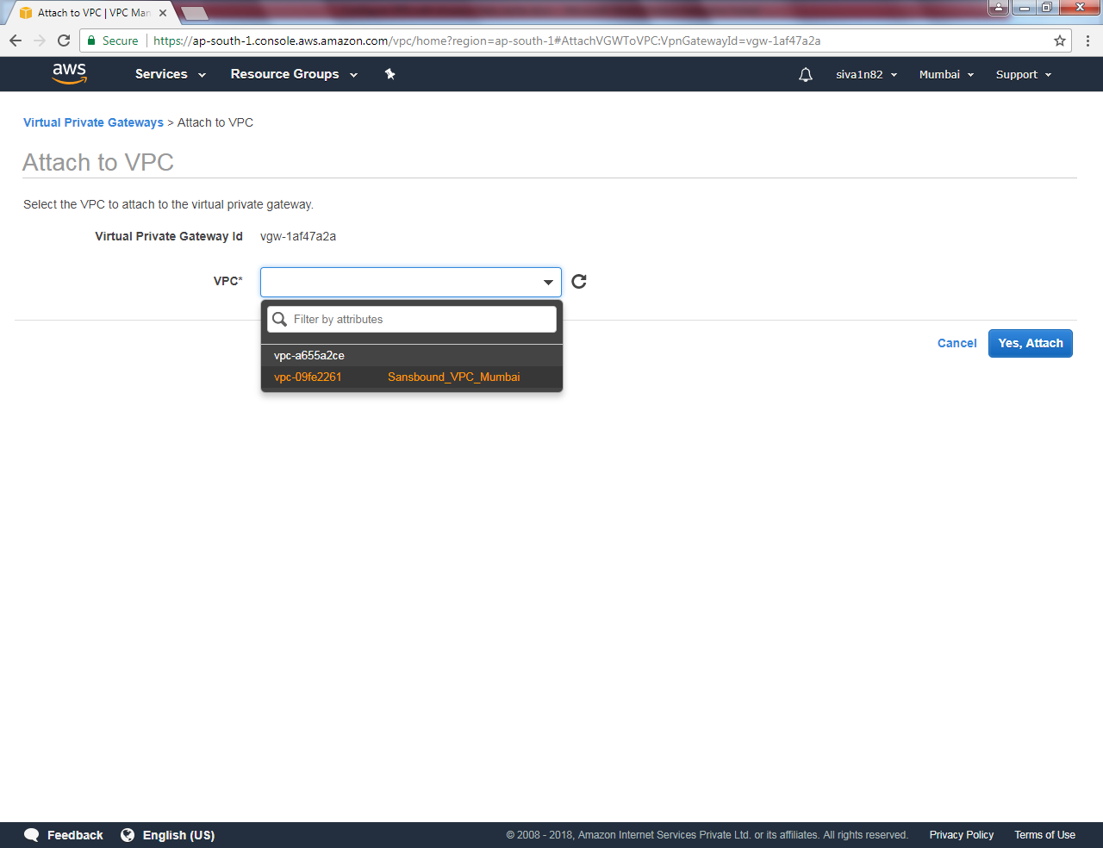

Click “Yes”.

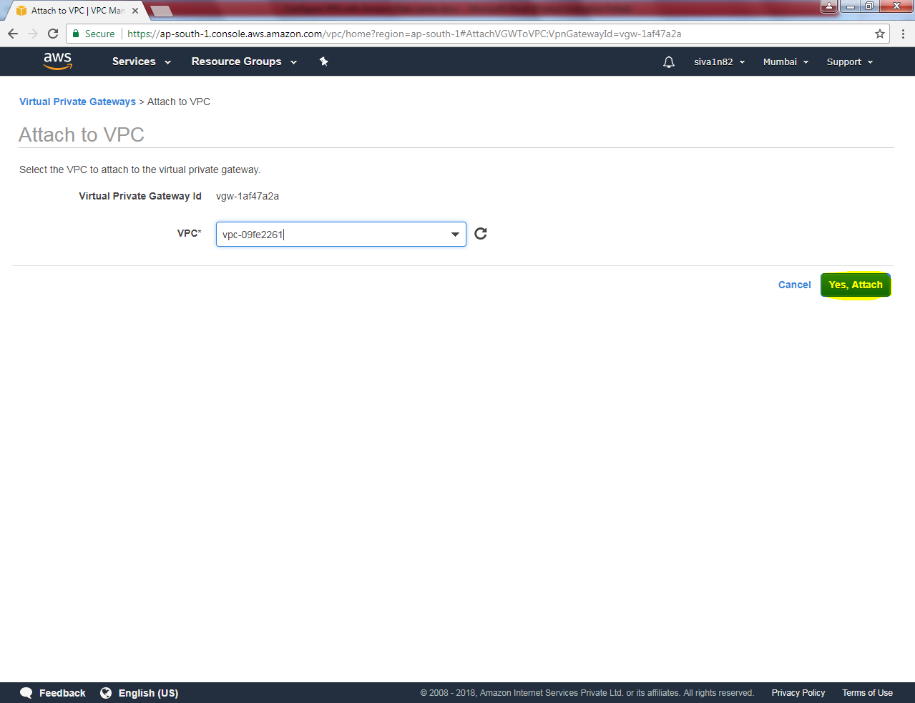

Now it’s attaching VPC with VPG.

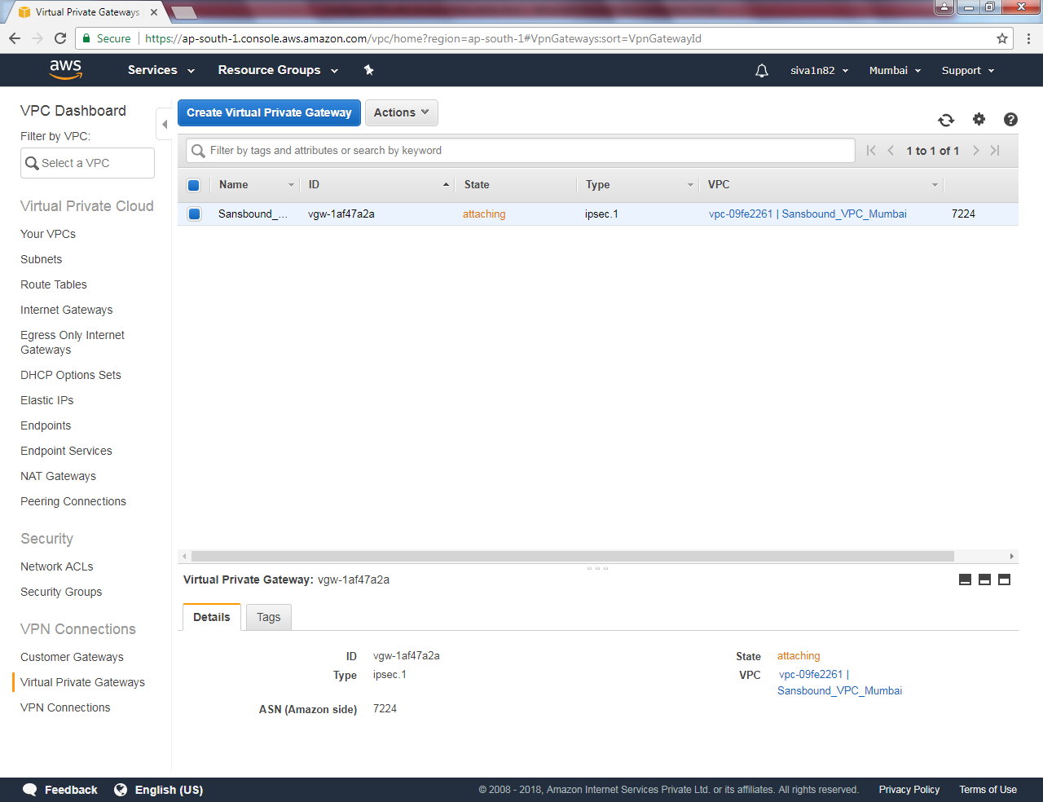

Now it’s attached VPG with VPC.

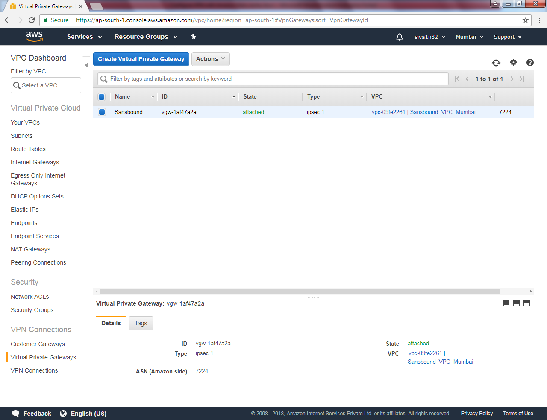

Click “Create Customer Gateway”.

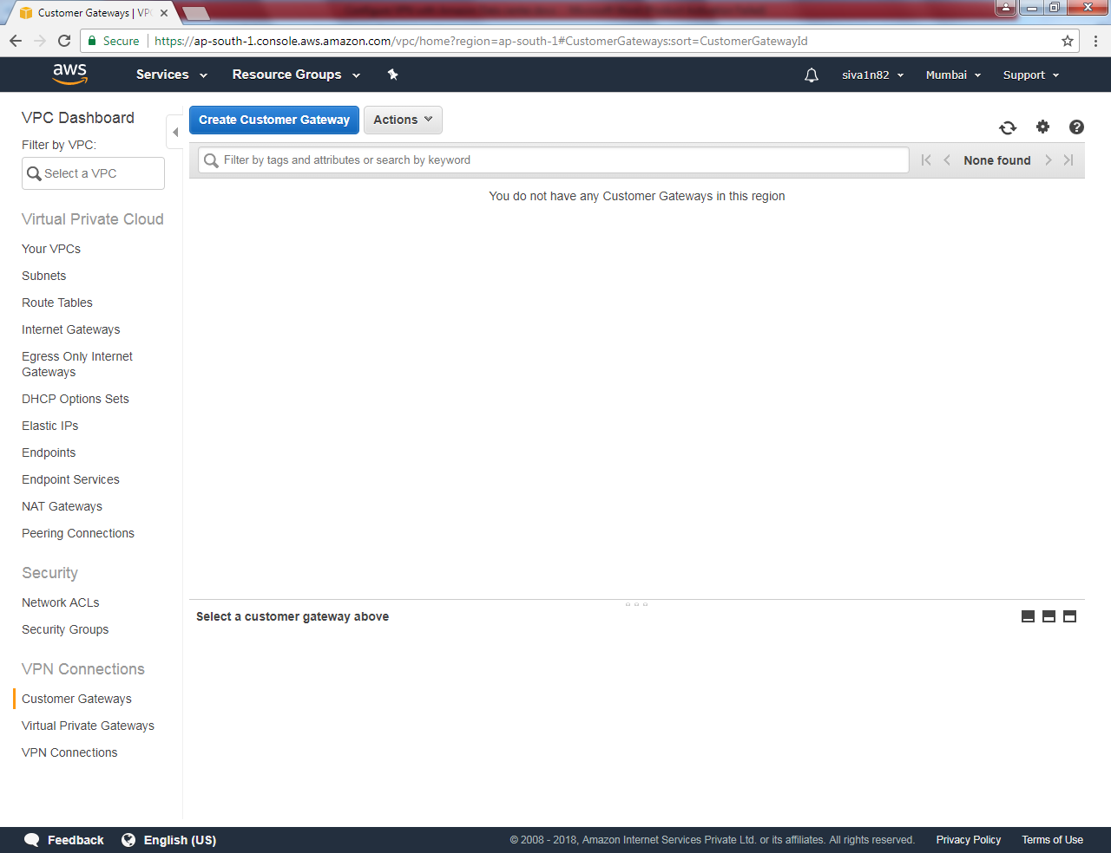

Type name as “Sansbound_Onpremieses

Routing as “Static”

IP address type customer / remote peer IP.

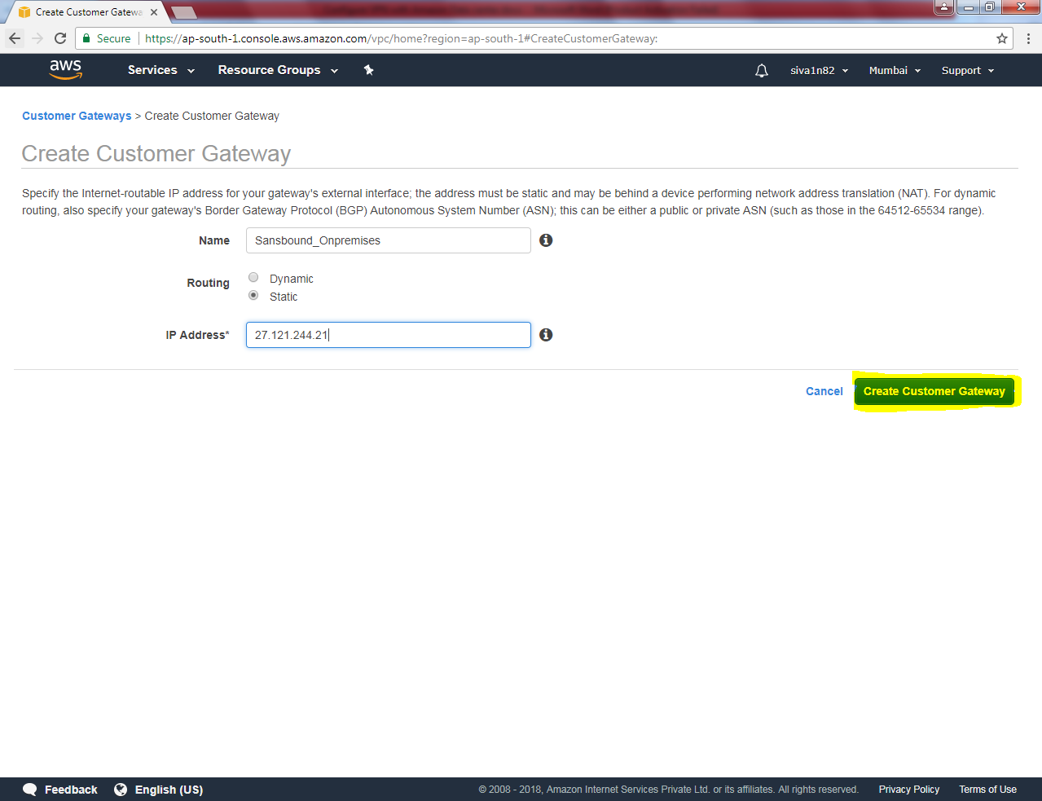

Click “Close”.

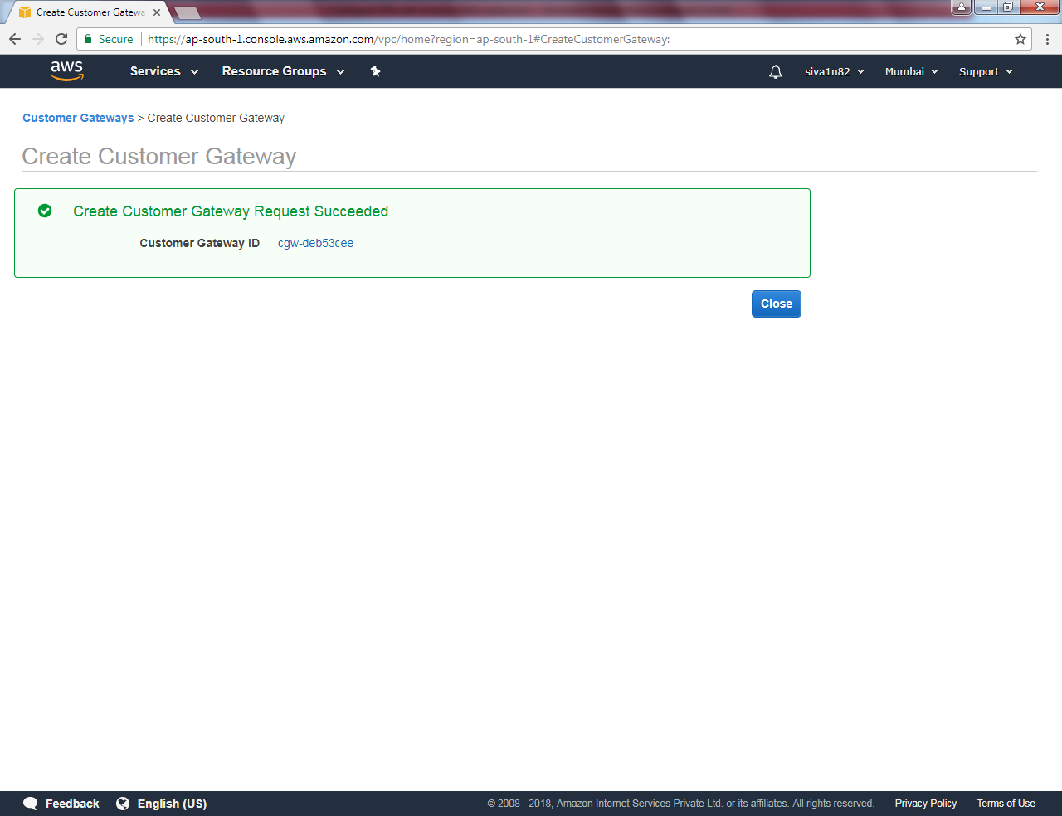

Now customer gateway is available.

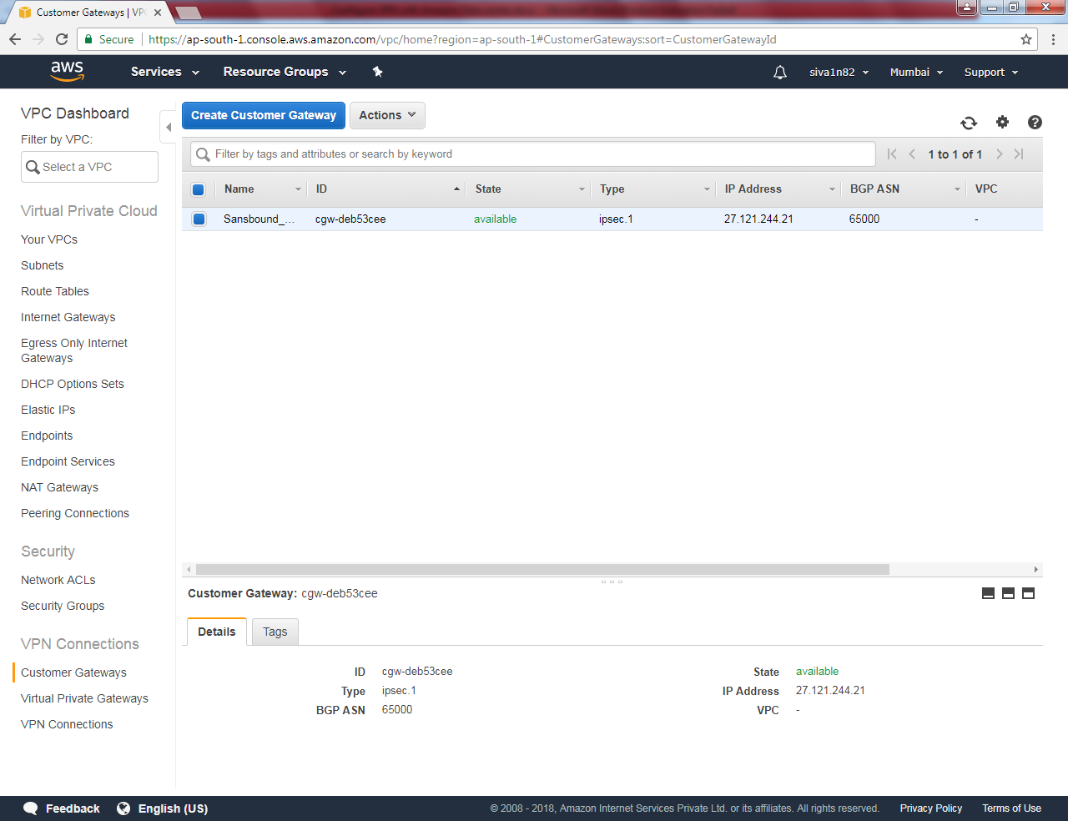

Now we need to create VPN connection.

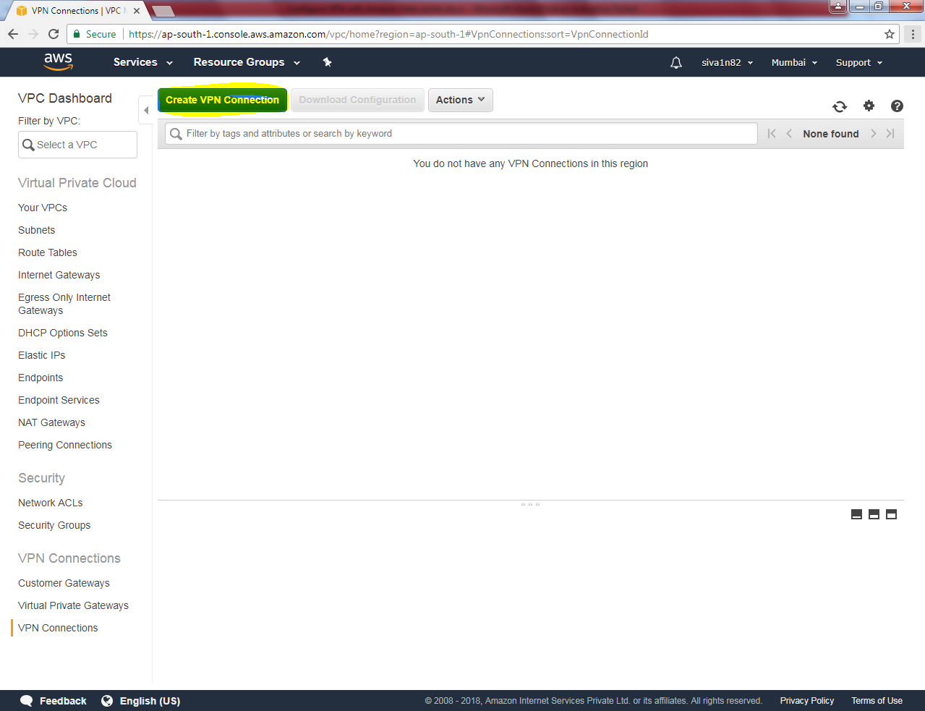

Name Tag: Sansbound_VPN

VPG: Select VPG

Customer Gateway : Use existing

Customer Gateway ID: Select the CG

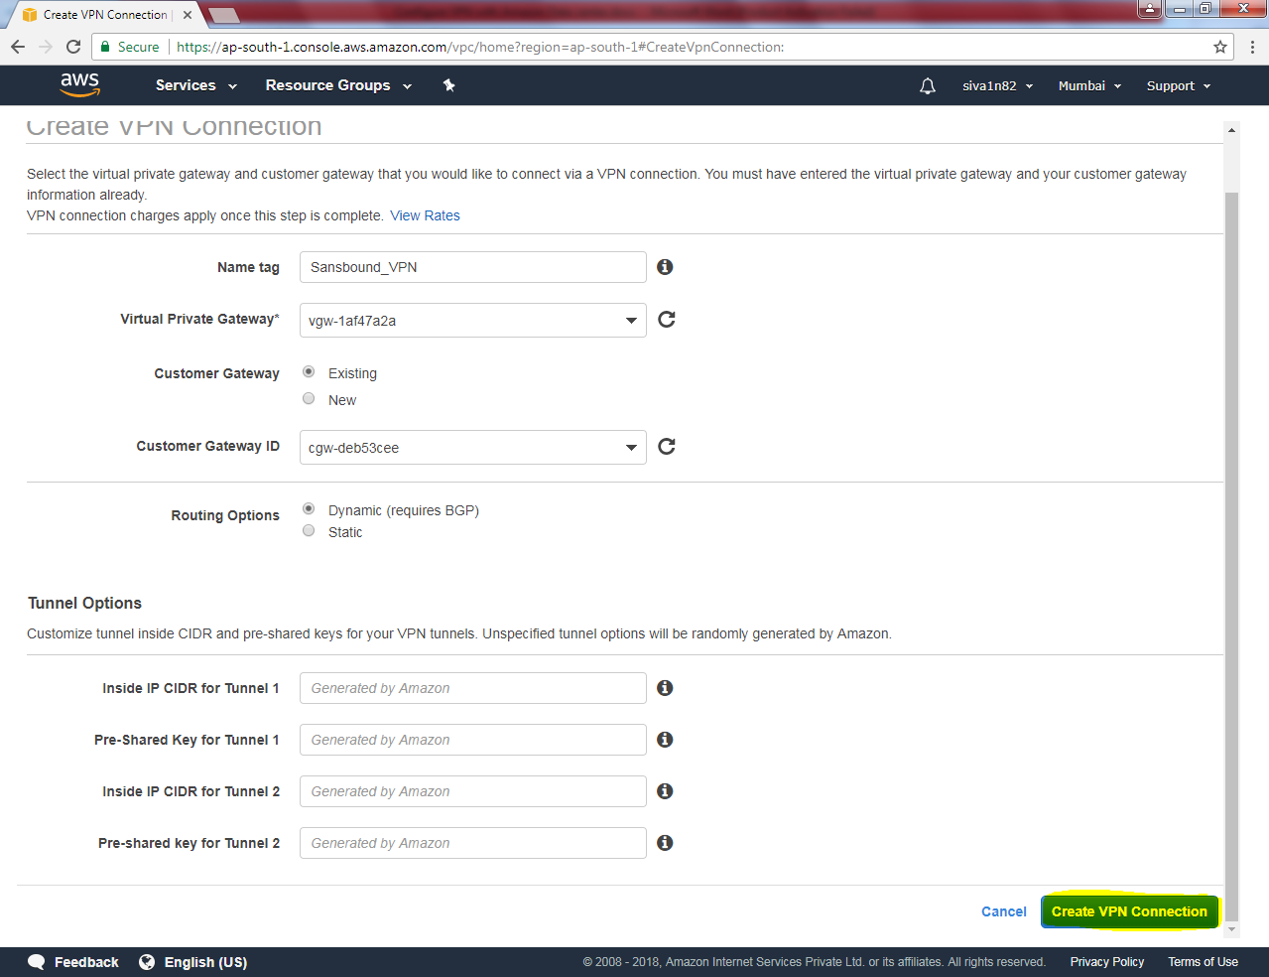

Click “Create VPN connection”.

Click “Close”.

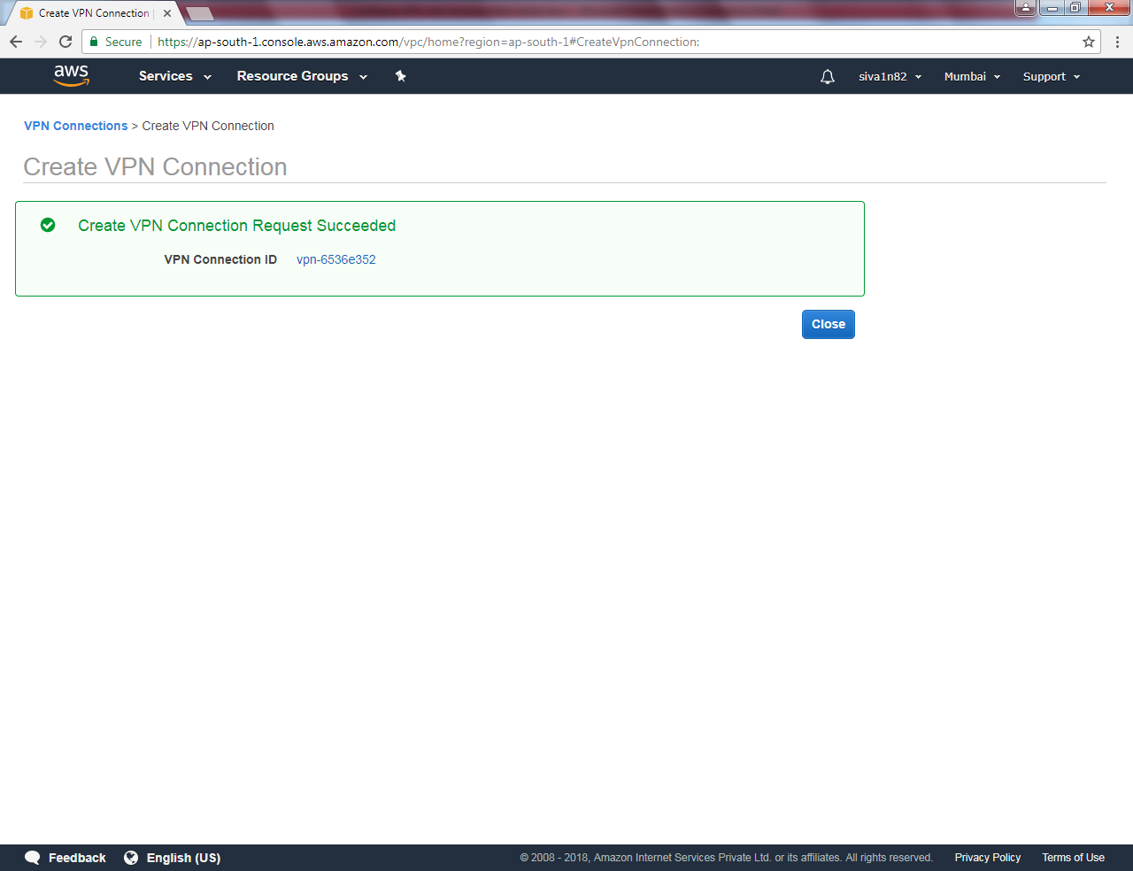

Now it’s pending because it was not valid Peer IP.

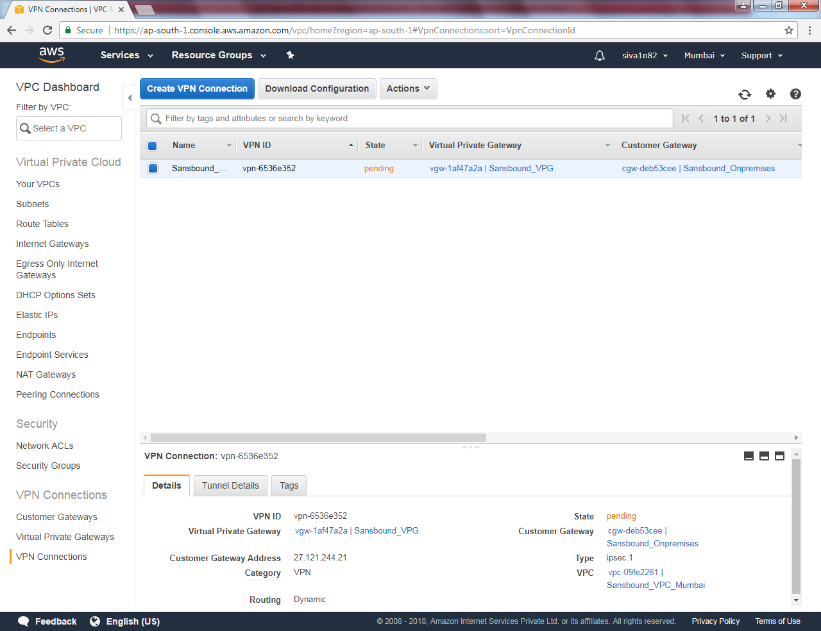

Click “Download configuration”.

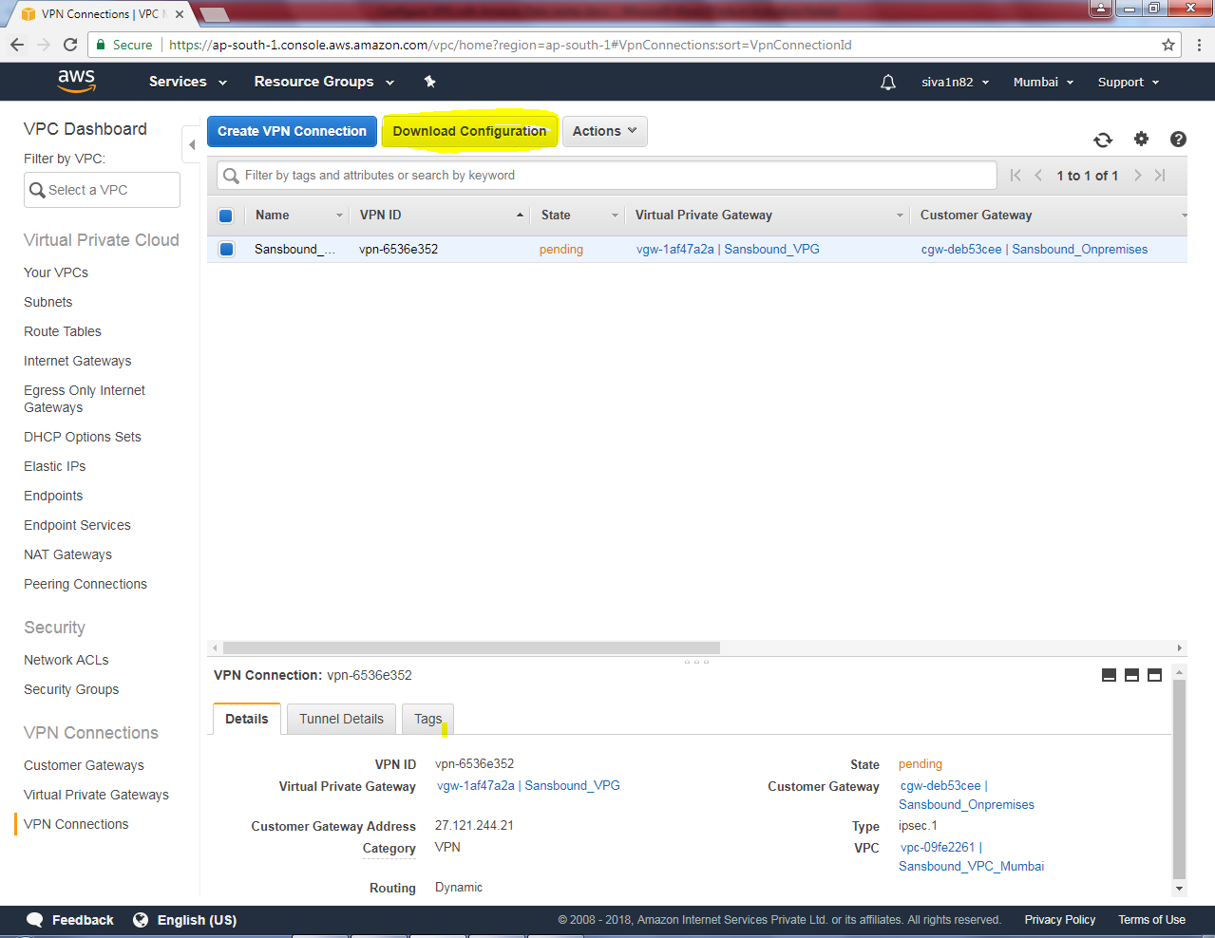

Select the vendor, platform and Software version.

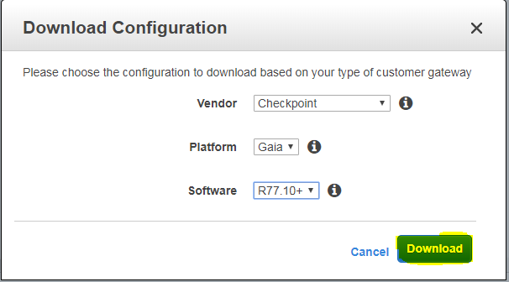

Click “Download”.

Output will not come, hence we need to delete VPN Connection.

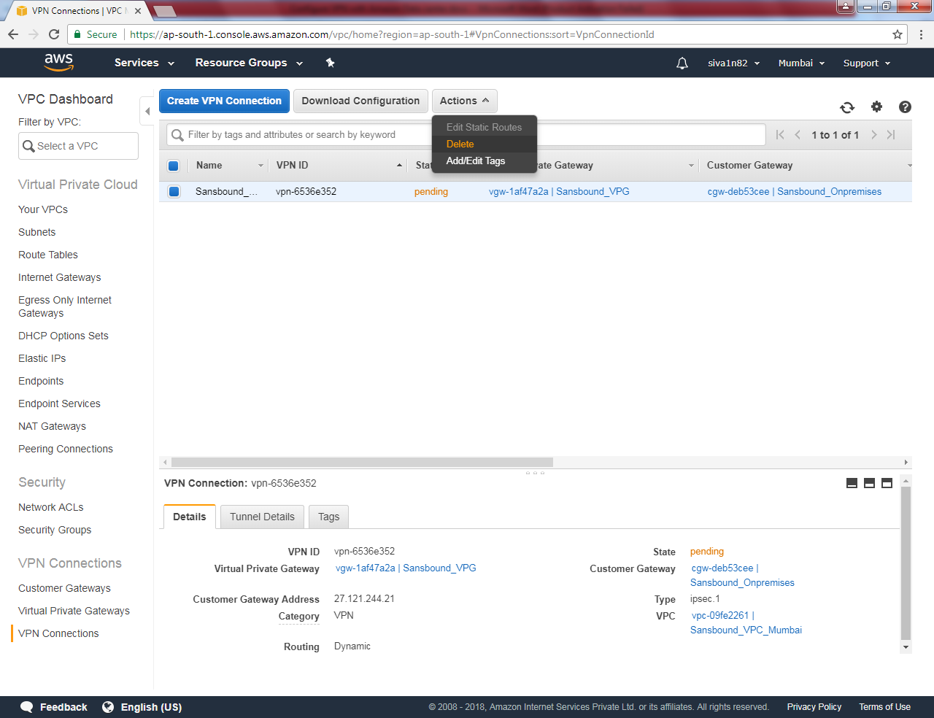

It Prompts, confirmation click “Yes” to delete.

VPN connection has been deleted.

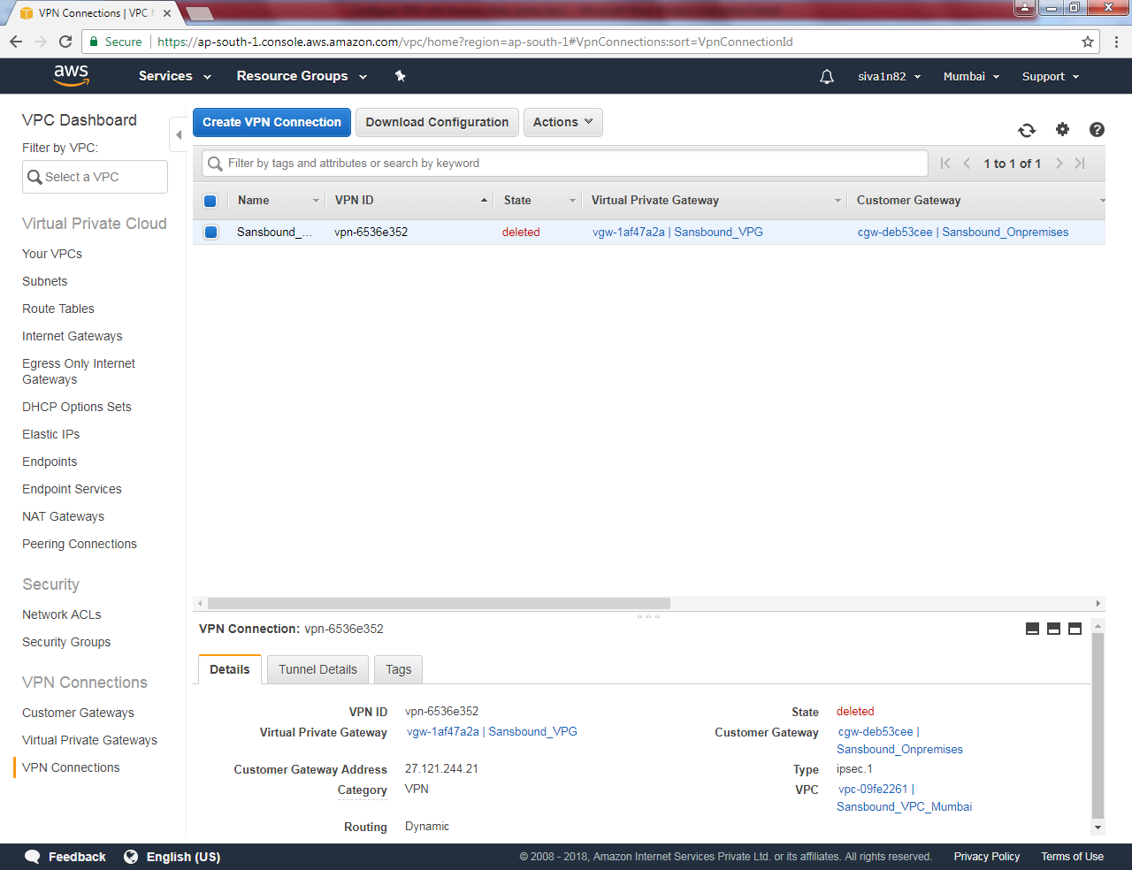

We have required to delete customer gateway.

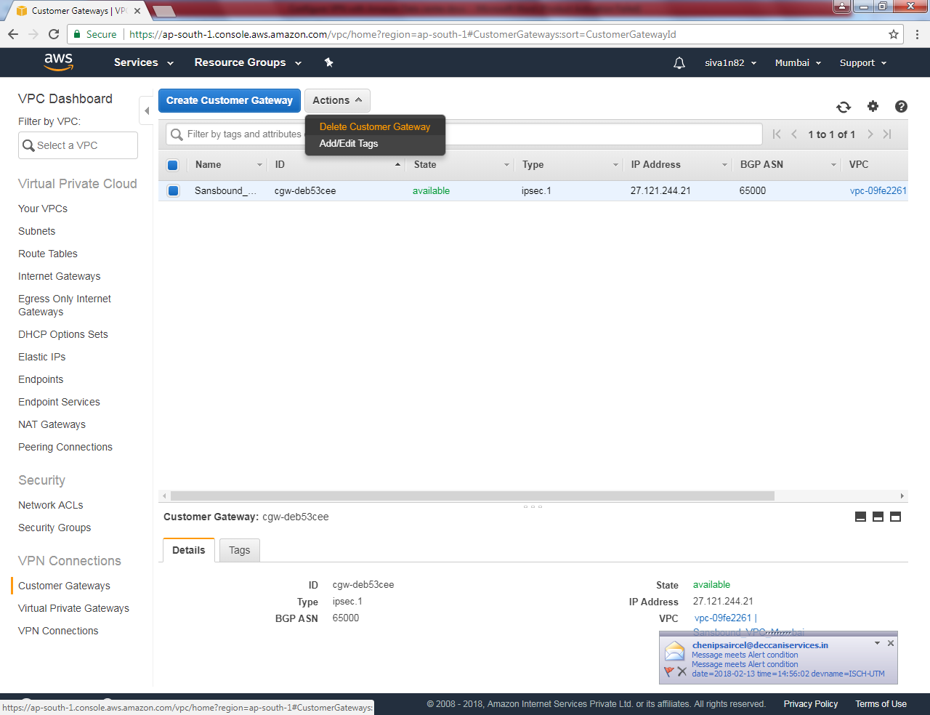

Click ”Yes, delete”.

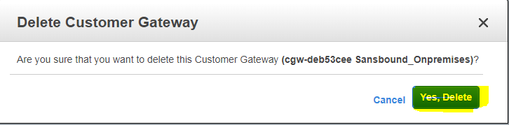

Click “Detach from VPC”.

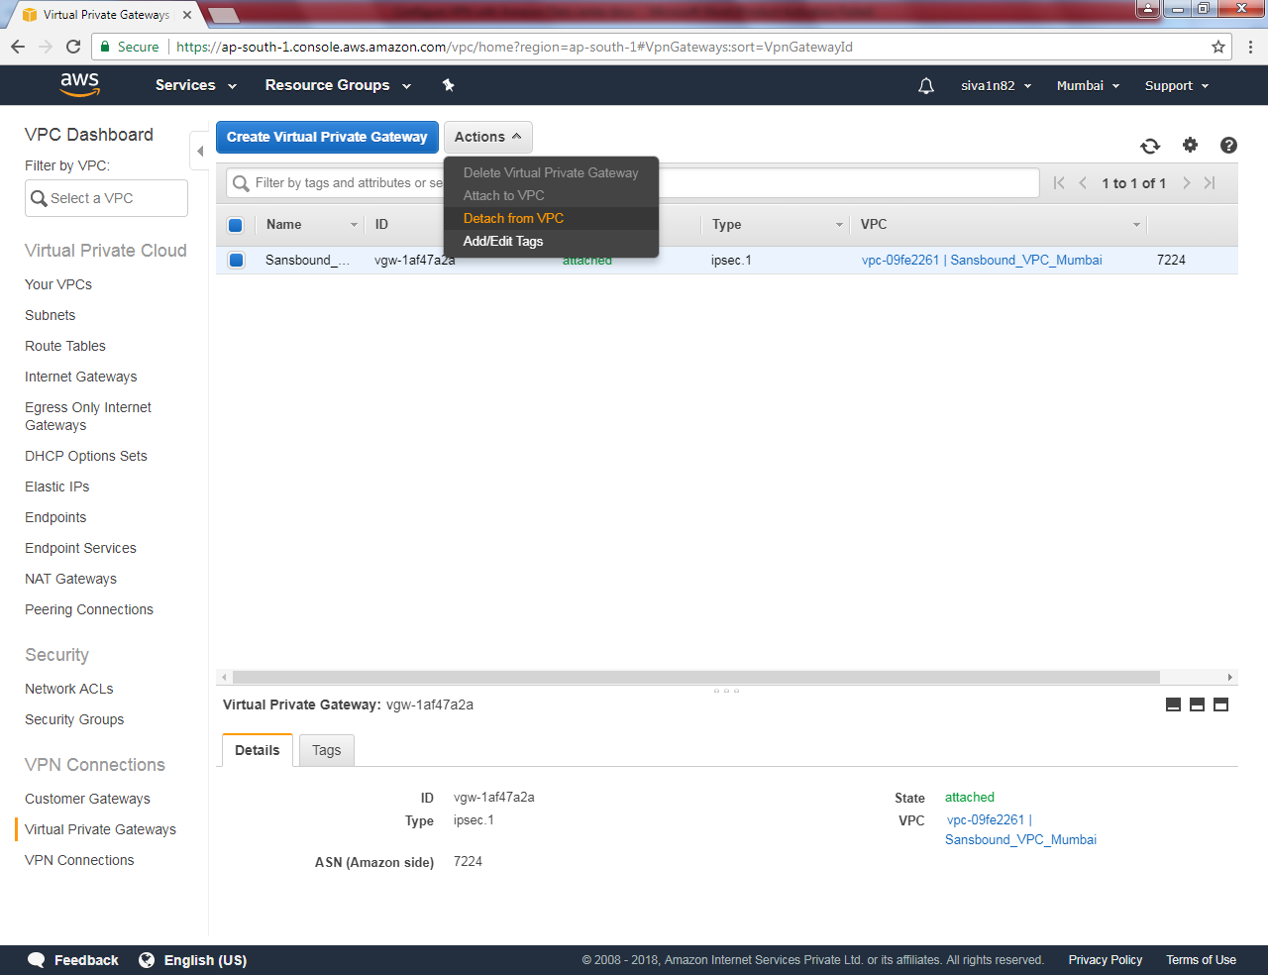

Click “Yes, Detach”.

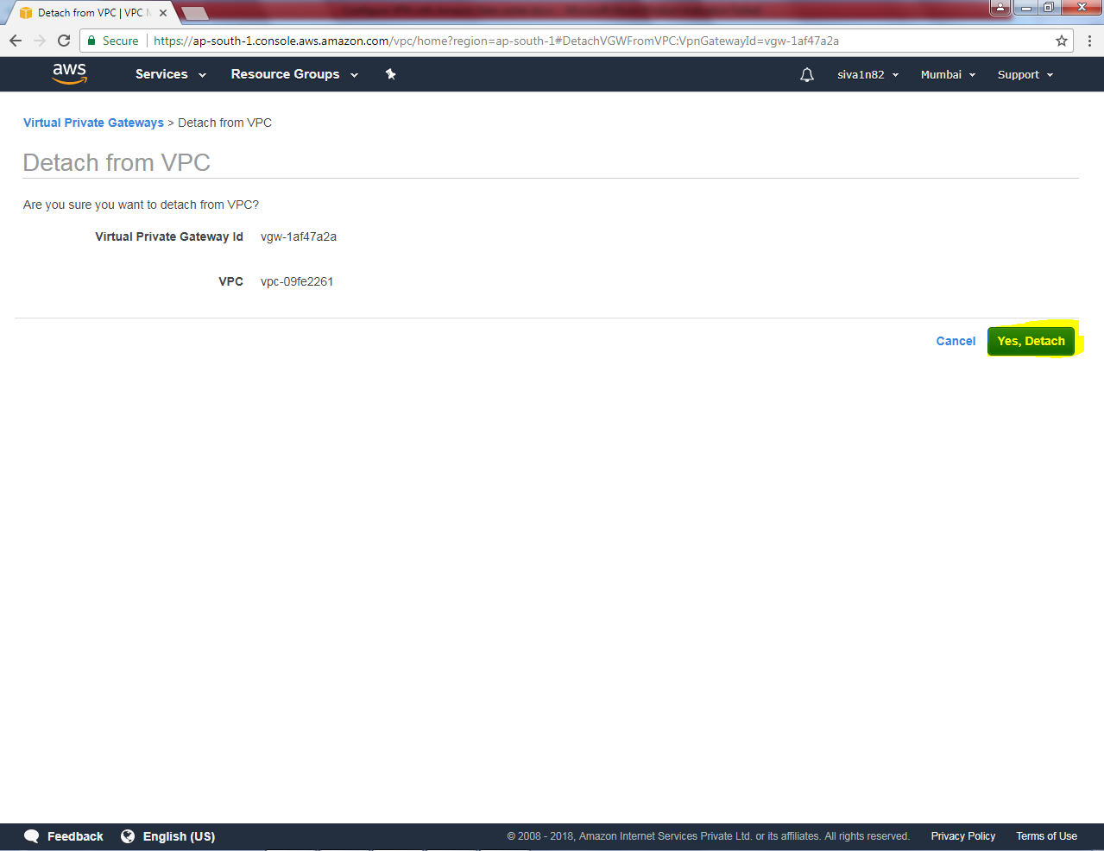

Now VPG is in detached state, we need to delete VPG.

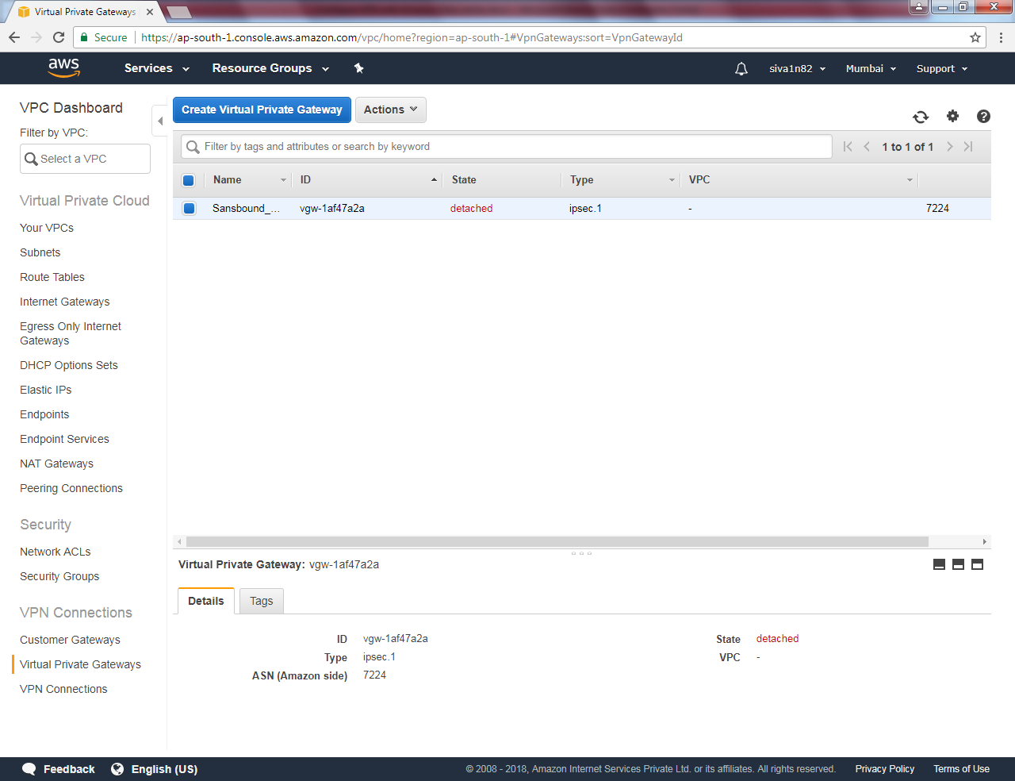

Click Actions 🡪 “Delete Virtual Private Gateway”.

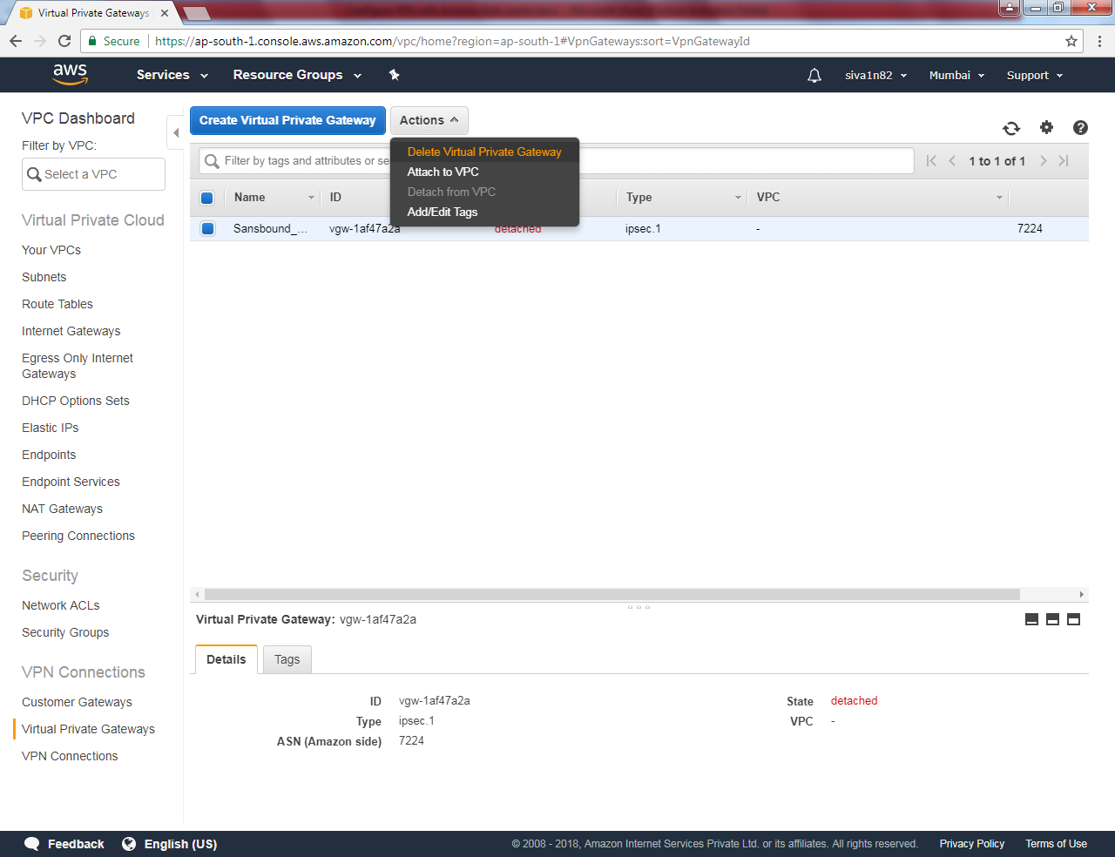

Click “Yes, Delete”.

